3D Numerical Study of the Elastic and Strength Properties of Ceramics with Cylindrical Pores
Alexey Yu. Smolin^{1, 2, a)}, Anna A. Shalomeeva^{2, b} and Irina Yu. Smolina^{3, c)}
¹Institute of Strength Physics and Materials Science SB RAS,
2/4, av. Akademicheskii, Tomsk, 634055, Russia
²Tomsk State University, 36, av. Lenina, Tomsk, 634050, Russia
³Tomsk State University of Architecture and Building, 2, sq. Solyanaya, Tomsk, 634003, Russia
^{a)}Corresponding author: asmolin@ispms.ru
^{b)}saa@ispms.ru
^{c)}smolina_i_yu@mail.ru

INTRODUCTION
Modern technologies of additive manufacturing make it possible to produce a material with very complex internal structure. The main structure elements for ceramic materials are their grains and pores. It is well known that porosity (volume fraction of pores) and pore structure (pore size, shape, curvature, interconnection etc.) are the main characteristics that determine the physical and mechanical properties of ceramics. In order to predict the material properties based on its structure, a number of the analytical approaches have been proposed [1]. However, these approaches allow predicting only elastic, thermal, and electromagnetic properties of the material. Regarding the strength, the capability of these approaches is limited to the periodic structure materials only. At the same time, novel computational techniques allow correct simulation of the material behavior from atomic up to macroscale. Taking into account all the aspects mentioned above, one might conclude that for predicting the properties of the advanced ceramics it is promising to use computer simulation [2–9].

DESCRIPTION OF THE MODEL
At present, finite element analysis, which is based on numerical solving the equations of continuum mechanics, is mainly used for simulating the mechanical behavior of materials at meso and macroscale [8, 9]. However, recently methods based on the discrete representation of material have been successfully developed and widely used [2–7]. One of them is the method of movable cellular automata (MCA), which assumes that the material consists of a set of elementary objects (automata), interacting with the forces determined in accordance with the rules of many-particle approach. MCA allows one to simulate all the aspects of the mechanical behavior of a solid at different scales, including deformation, initiation, and propagation of damages, fracture and further interaction of fragments after failure [6, 7]. An automaton motion is governed by the Newton-Euler equations. The forces acting on automata are calculated using deformation parameters, i.e. relative overlap, tangential displacement, and rotation, and conventional elastic properties of the material, i.e. shear and bulk moduli. A distinguishing feature of the method is calculating of forces acting on the automata within the framework of multi-particle interaction, which among other advantages provides for an isotropic behavior of the simulated medium.
A pair of the elements may be considered as a virtual bistable automaton that can be in one of two stable states (bonded and unbonded), which permits simulation of fracture and coupling of fragments (or crack healing) by MCA. These capabilities are realized by means of the corresponding change of the state of the pair of automata. A fracture criterion used in simulation essentially depends on the physical mechanisms of material deformation. An important advantage of the MCA formalism is that it makes possible direct application of conventional fracture criteria (Huber-Mises, Drucker-Prager, Mohr-Coulomb, etc.), which are written in the tensor form [7].
A number of previously published studies have proved that MCA is very promising for modeling fracture of ceramics. Aniszewska et al. showed that this method allows correct simulation of strength and its uncertainty of ceramics macrospecimens of different porosity both in compression and torsion [2, 3]. Smolin et al. proposed to use uncertainty estimates obtained from simulation of the model specimens with an explicit account for pores for multiscale simulation of ceramics [4, 5]. All the above-mentioned papers dealt with equiaxed pores. Roman studied the model ceramic specimens with cylindrical pores identically oriented in space [6]. He showed that the cylindrical pores inclined at 45° with respect to compression direction possess minimal strength and elastic modulus.
Herein we present a model based on MCA method for 3D simulating zirconia ceramics with cylindrical pores differently oriented in space. Namely, we considered two types of porous structure of cylindrical pores. The specimens of the first type contained the pores inclined at 45° with respect to the compression direction, as shown in Fig. 1 i.e. when all pores have the same orientation. For the specimens of this type, the total porosity varied from 5 % up to 20 %.
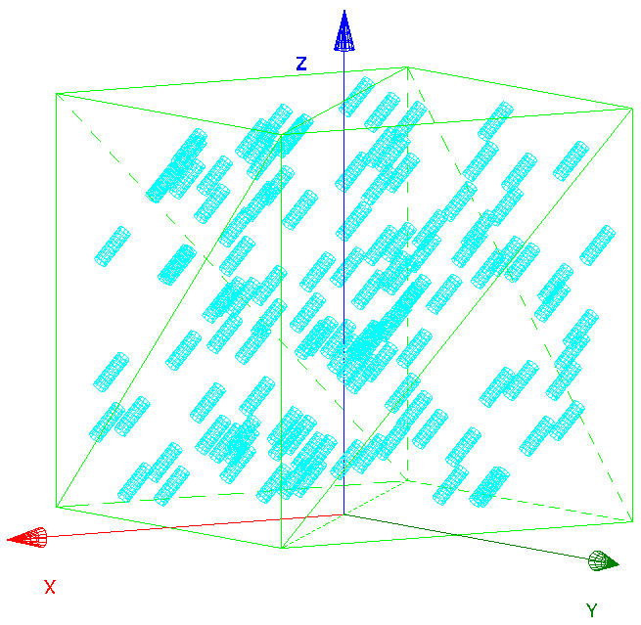 | 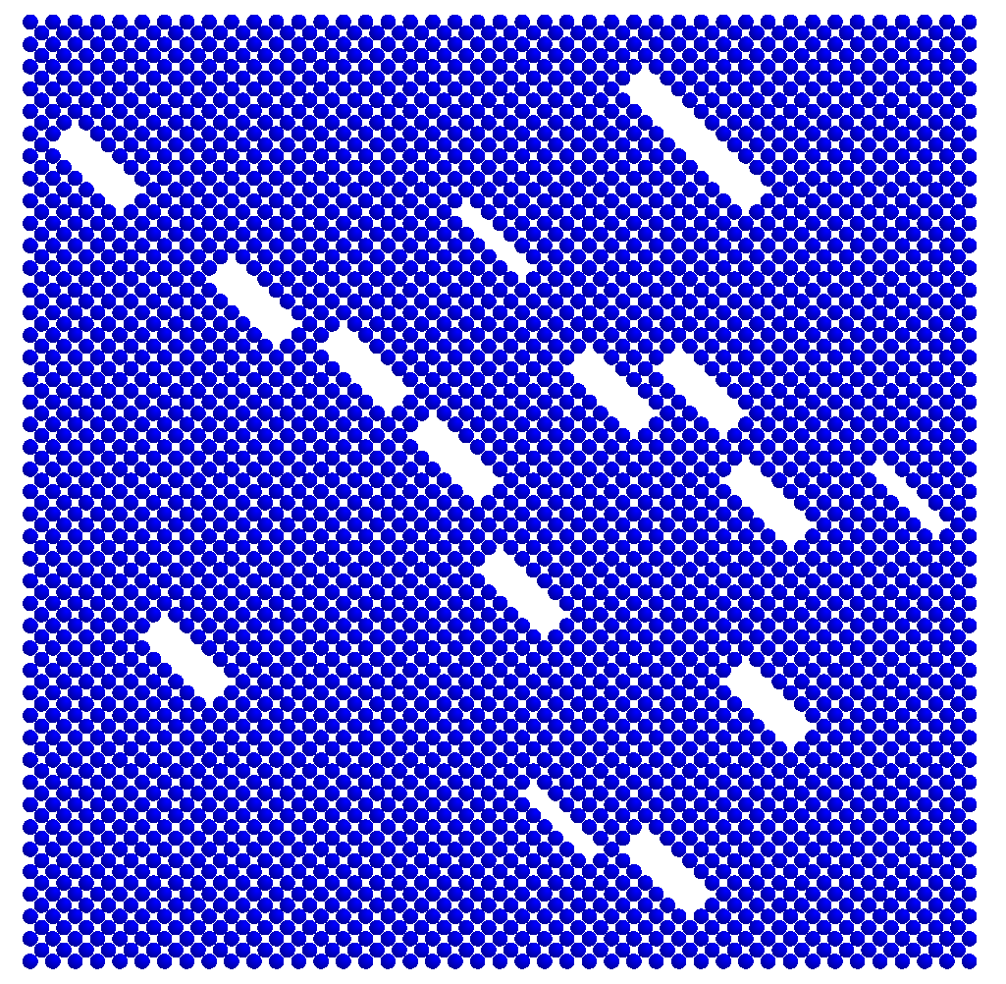
(a) | (b)
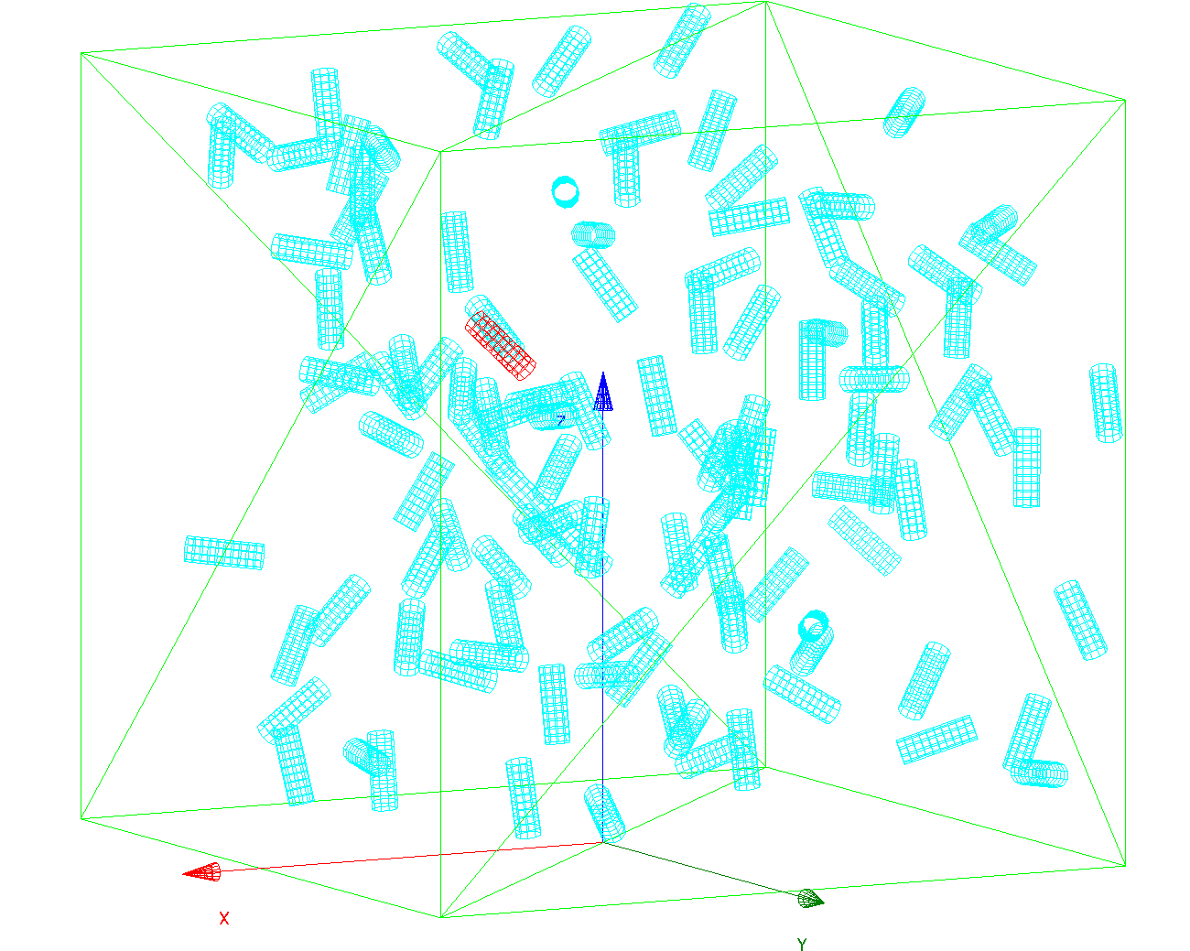
(c)
Figure 1. (a) Schematic of unidirectional cylindrical pores placed in a cubic specimen; (b) cross-section of the corresponding modeled specimen filled by fcc-packed cellular automata; (c) schematic of the randomly oriented pores

The second type of porous structure was obtained by random rotation of the initial pores shown in Fig. 1 about axis Z. To avoid merging of the pores we varied fraction of this type of pores from 5 % to 11 % because it is difficult to manage close packing of randomly oriented cylinders.
The pore diameter was equal to 100 μm, the height 300 μm. The automaton size was equal to 50 μm, the specimen size 3 mm. The response function of automata corresponded to the loading curve for nanocrystalline ZrO₂(Y₂O₃) with a total porosity of 2% [5]. Inter-automaton bond rupture criterion used in calculations was formulated as a threshold value for equivalent shear stress.
For each porosity value, there were considered five representative specimens with pores of the same size and orientation but with the unique position in space. We simulate uniaxial compression (along axis Z) of these specimens. Using the loading curve obtained from the simulation, the elastic modulus in compression (the slope of the linear part of the curve) and the compression strength (its maximum value) were determined for each specimen. The Poisson’s ratios along axis X and Y were determined by the displacement of four gauge automata positioned at outside planes of the specimen along the corresponding axis. All these values are random variables due to random pore arrangement. As shown, for example, in [10] the failure process is governed by Weibull distribution model, which assumes the following cumulative distribution function
(1)
where η is the scale parameter, and β is the shape parameter. To estimate the values of η and β in the case of a small random sample size, it is recommended to use the median rank regression, which is reduced to the transformation of Eq. (1) to a linear equation, and to the linear approximation of this equation by means of simple least-square regression. In our work, we used a special package designed for the statistical programming language R, providing basic functionality needed to perform Weibull analysis available at [11].
Knowing the parameters of the distribution function (1) for each mechanical property allows us to compute the mathematical estimate, which is assumed to be an effective property for the specimen of this porosity value and pore structure.

MODELING RESULTS
Figure 2 shows normalized Young’s modulus and compression strength versus porosity for all the porosity range used in computations (here E₀ and σ₀ are the values of Young’s modulus and strength limit of the compact ceramics). As one can see the scatter for strength value (Fig. 2, b) is much larger than for elastic modulus (Fig. 2, a). Nevertheless, the modeling results in Fig. 2 can be well approximated by the power function
, (2)
where C_{max}, C₀, and m are adjustable parameters. The fitting curves are shown in Fig. 2 as yellow lines for the specimens with pores oriented in one direction (these points are marked as “α_{y}=45°”) and as cyan lines for the specimens of the second type of pore structure (these points are marked as “rand”). Random orientation of the cylindrical pores along the compression direction has no influence on the elastic modulus along this direction (Fig. 1, a), but increase the strength value up to 10 % (Fig. 1, b).

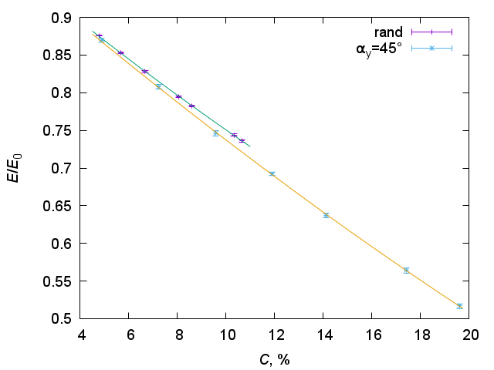 | 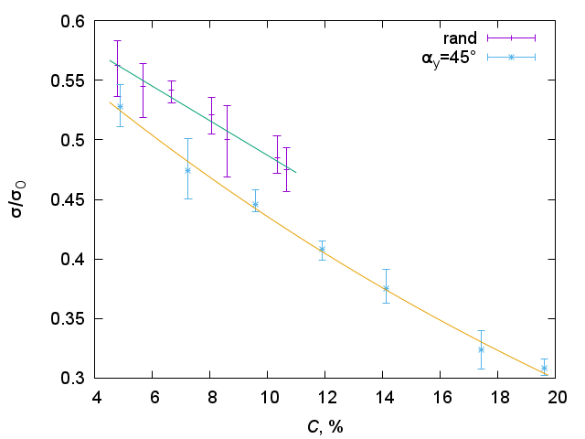
(a) | (b)
Figure 2. (a) Normalized Young’s modulus versus porosity and (b) normalized compression strength versus porosity for two group of specimens with unidirectional cylindrical pores (α_{y}=45°) and randomly oriented pores (rand)

Figure 3 depicts the resulting Poisson’s ratios along two lateral directions (exes X and Y) versus porosity for two types of pore structure. For unidirectional pores, it is obvious that the values of Poisson’s ratio ν_{x} along axis X (Fig. 3, a) is smaller than Poisson’s ratio ν_{y} along axis Y because the cross section perpendicular to axis Y contains elongated pores (Fig. 1, b) while the conjugated section contains circular pores. The curves in Fig. 3, a also shows that ν_{x} decreases with an increase of porosity faster than ν_{y} for the specimens with unidirectional pores. For the specimens with randomly oriented pores, the values of Poisson’s ratio along both axes are approximately the same taking into account a large scatter of the values. It is interesting to note that for this type of pore structure the magnitude of Poisson’s ratio decrease with porosity increasing (the slope of the cyan curves in Fig. 3) corresponds to decrease of ν_{x} for unidirectional pores (the slope of the yellow curve in Fig. 3, a).

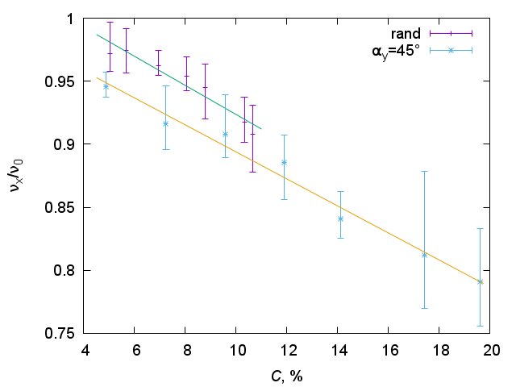 | 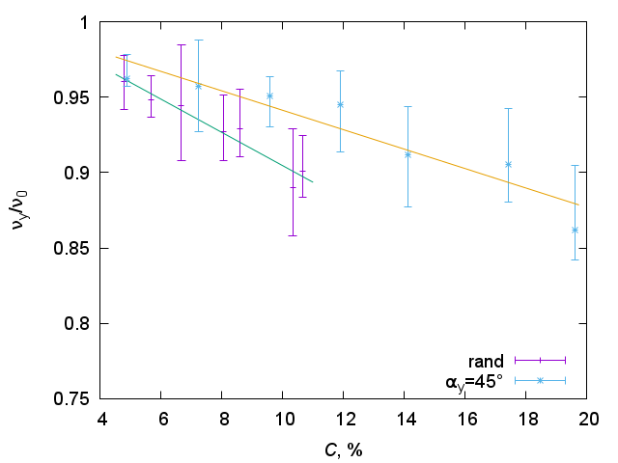
(a) | (b)
Figure 3. Normalized Poisson’s ratio along X axis (a) and Y axis (b) versus porosity for two types of pore structure: unidirectional cylindrical pores and randomly oriented pores

Summarising the obtained results, we can conclude that the proposed MCA model allows simulating and studying the deformation and fracture of the ceramics with elongated pores. The simulations of five specimens with the unique position of individual pores for each value of total porosity show that there is no scattering of elastic modulus values while the scatter of strength and Poisson’s ratio values is significant. Random orientation of elongated pores results in higher strength value and does not change Young’s modulus of the model ceramics.

References
- I. Sevostianov, in Effective Properties of Heterogeneous Materials in “Solid Mechanics and Its Applications”, edited by M. Kachanov and I. Sevostianov (Springer, 2013, V. 193), p. 389.
- D. Aniszewska, Theor. Appl. Fract. Mech. 62, 34–39 (2012).
- J. Czopor, D. Aniszewska, M. Rybaczuk, Comput. Mater. Sci. 51, 151–155 (2012).
- A. Yu. Smolin, I. Yu. Smolin, I. Yu. Smolina, AIP Conf. Proc. 1893, 030127-1 (2017).
- A. Yu. Smolin, N. V. Roman, I. S. Konovalenko, G. M. Eremina, S. P. Buyakova, S. G. Psakhie, Eng. Fract. Mech., 130, 53–64 (2014).
- N. V. Roman, “Multiscale simulation of deformation and fracture of brittle porous materials by movable cellular automata,” Ph.D. thesis, Tomsk State University, 2012. (in Russian)
- E. V. Shilko, S. G. Psakhie, S. Schmauder, V. L. Popov, S. V. Astafurov, A. Yu. Smolin, Comput. Mater. Sci., 102, 267–285 (2015).
- I. Yu. Smolin, P. V. Makarov, M. O. Eremin, K. S. Matyko, Proc. Struct. Integrity, 2, 3353–3360 (2016).
- K. A. Acton, S. C. Baxter, B. Bahmani, P. L. Clarke, R. Abedi, Comput. Methods Appl. Mech. Engrg. 336, 135–155 (2018).
- H. Rinne, The Weibull Distribution. A Handbook (CRC Press, 2009) p. 762.
- Implementation of functions supporting reliability analysis methods presented in “The New Weibull Handbook” by Dr. Robert B. Abernethy, see http://r-forge.r-project.org/projects/abernethy/

